William S. Hart on DVD: Ben Hur
Bill West
Howdy folks! You may remember I used to write articles on William S. Hart films on DVD for the membership newsletter, “Hart of the Matter”. Well, I never did finish that series, and since then, many new Hart movies have become available, including the one I’ll talk about here. So, let’s start up the series again, what’s say!? Like before, I’ll go chronologically through the movies Hart made that are available on DVD, starting WAY back in 1907...
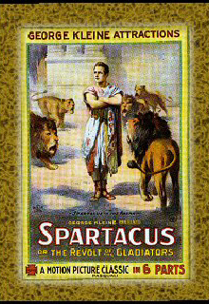
“Ben Hur” was an amazing find for us Hart-on-DVD collectors. I had seen it in lists of his films, but honestly didn’t believe it existed... This was William S. Hart in his stage performing days, when he had created the role of Messala for the play Ben Hur. It was so popular, it was decided to film parts of the play! That makes “Ben Hur” not only the first filming of the book Ben-Hur, but the very first William S. Hart movie as well!
Much to my surprise, Ben Hur IS available on DVD! I know of only one source, and that’s from Grapevine Video. (Grapevine, by the way, has a few Hart movies, including a rare non-western called “Cradle of Courage”. My favorite “Hart find” of theirs is a 1941 visit with Bill Hart at his home in Newhall, by Hollywood gossip columnist Hedda Hopper!) To get Ben Hur on DVD, visit Grapevine Video by going to www.grapevinevideo.com/Spartacus.html.
Why Spartacus? Well, that’s because the main movie on the DVD is a silent, Italian-made 1913 version of the story of Spartacus. Ben Hur is just a bonus feature on the DVD since it’s only 13 minutes long... That gives you a sense of how little of the full Ben Hur story is represented here. It’s really just some highlights.
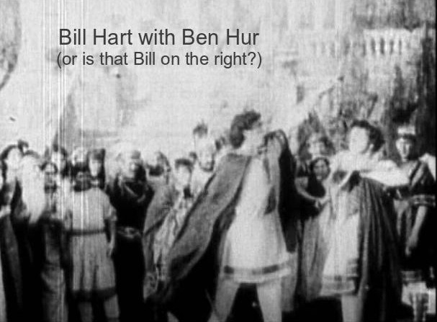
The best part is the chariot scene, which was filmed on a beach in New Jersey, using the local fire department’s horses, with fireman playing the non-principal chariot drivers!
Now, if you remember my articles from Hart of the Matter, you know I almost never see a Hart movie that I don’t love... well, this is one of those rare exceptions, for two reasons: 1., the movie is so chopped up, it’s rather difficult to follow, and 2., the quality is horrible. It was, after all, 1907.
Still, if you were expecting to see a young, dashing, William S. Hart, I should warn you.. the only way you can even TELL that it’s Hart you’re seeing is because of his 6’3” height relative to the other actors... the quality of the images is that bad.
But, if you’re a Hart-DVD-Collecting-Completist like me, you’ll have to have it too!
There’s one other reason to own it, for its historical significance. Ben Hur has the distinction of being the first film whose makers were sued by copyright owners of the book for filming their story without permission. This was the landmark case that enforced copyright laws thereafter in film.
I’ll be back with Hart’s first feature film next time -- and this one is a good one -- “The Bargain”.

